CSA1503-Cloud computing and big data analytics
Experiment-11
Create a simple cloud software application for online super market using any Cloud Service Provider to demonstrate SaaS with the template of customer name, address, phone, email, items, quantity etc. with the item classification form.
Input:
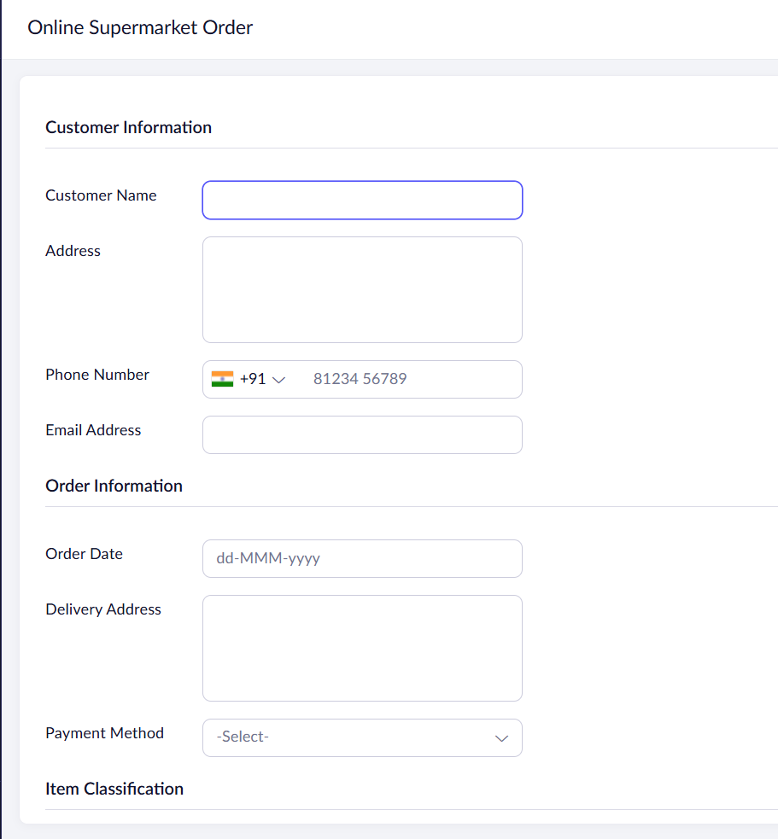
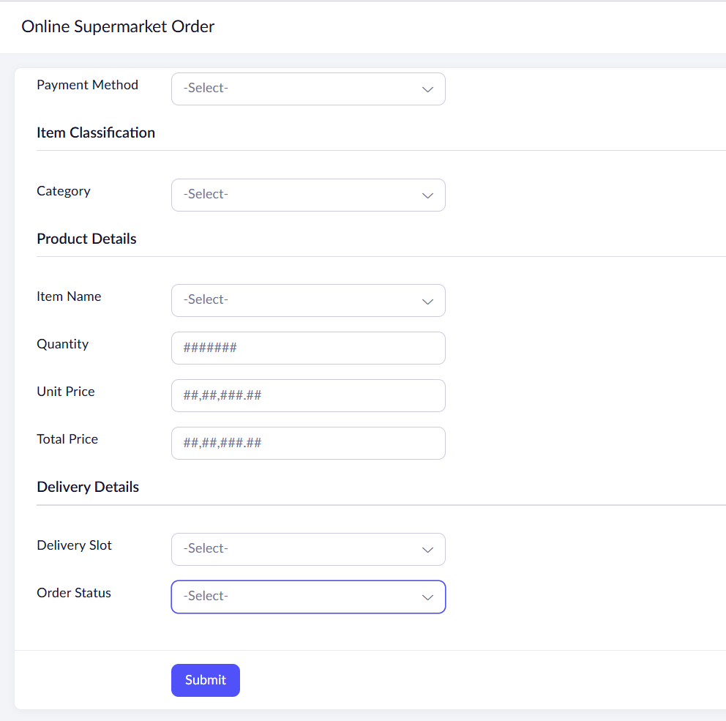

Output:
